Question 2 Notes

Question 2 A
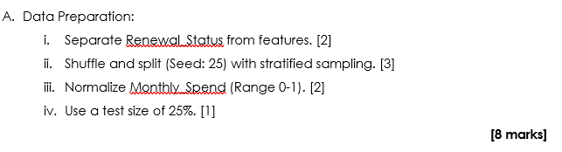
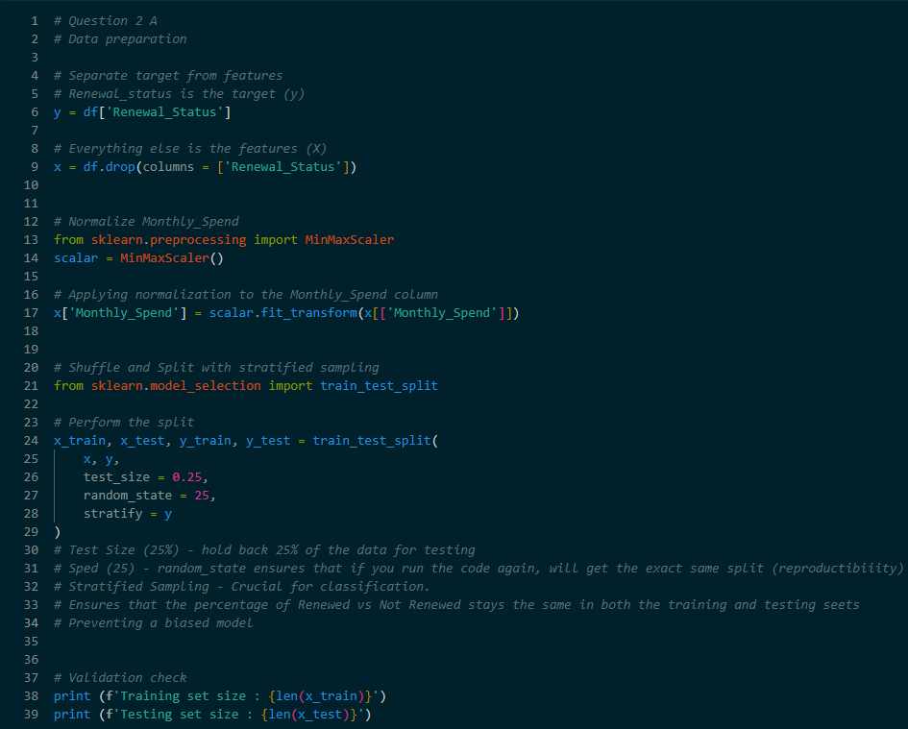
- Before building the machine learning model, ensure that the data must be cleaned and organized
- Separating Target and Features
  - Define y as the Renewal_Status and x as all other columns

- Normalization
  - The Monthly_Spend column is scaled to a range between 0 and 1 using MinMaxScaler. This ensures that large numbers do not unfairly influence the model compared to smaller numbers
- Data Splitting
  - Test Size : 25% of the data is kept aside to test the model’s accuracy on unseen data
  - Seed(Random State): Setting this to 25 ensures that every time run the code, the data splits in the exact same way for consistency
  - Stratified Sampling : This ensures that the ratio of Renewed to Not Renewed is the same in both the training and testing sets, preventing the model form becoming biased toward one results

Question 2 B
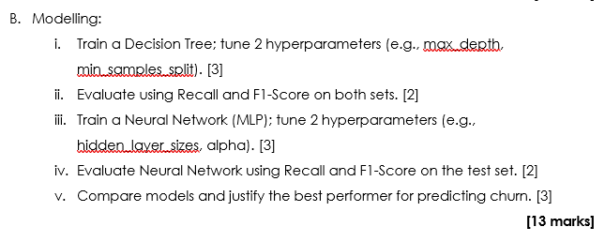
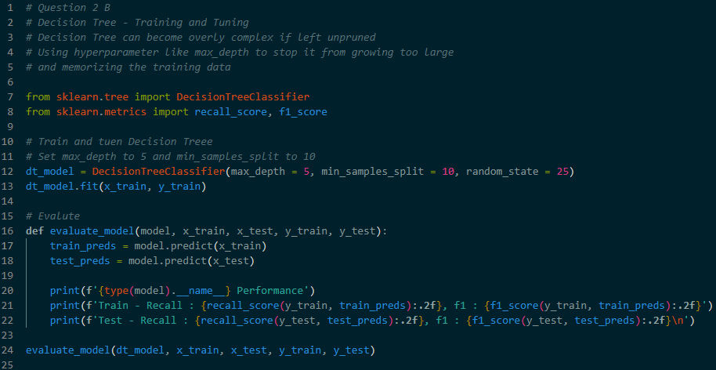
- Decision Tee acts like a flowchart to make predictions based on the data features
- Training
  - The model learns patterns from the x_train and y_train data
- Hyperparameter Tuning
  - Manually set limits to prevent the model from becoming too complex
  - max_depth – limits how deep the tree grows
  - min_samples_split – The minimum number of data points required to create a new branch
- Evaluation Metrics
  - Recall – Measures how well the model finds all the customers who actually churned
  - F1-Score – A balance between precision and recall, providing a single score for overall accuracy

